Comparative analysis of machine learning model for skin cancer detection

Abstract

Detecting and classifying skin lesions in an early manner is crucial for the prevention of skin cancer, which is still a major global health concern. For the purpose of classifying skin lesions into seven categories—melanocytic nevi, melanoma, basal cell carcinoma, actinic keratoses, vascular lesions, and dermatofibroma—we compare machine learning and deep learning methods in this study. To improve model generalisation, we preprocess the data using resizing and augmentation techniques by utilising the HAM10000 dataset, which provides a variety of samples of skin lesions. We use multiple models in our analysis: a Decision Tree classifier, Linear Regression, K-Nearest Neighbours (KNN), Random Forest, and a Convolutional Neural Network (CNN) specifically constructed for skin lesion classification. We use appropriate optimisation approaches to train each model, and we assess each model's performance using measures like accuracy, precision, recall, and F1-score on a held-out test dataset. We also examine class distributions and confusion matrices to obtain further understanding of the advantages and disadvantages of the approach. The outcomes of the experiment show that deep learning techniques, in particular the CNN model, are successful in correctly diagnosing skin lesions with an accuracy of 82%. Still, conventional machine learning algorithms like Random Forest (33%) and KNN (55%) demonstrate competitive performance as well, highlighting their importance in the detection of dermatological conditions. While Decision Tree produced an accuracy of 47%, Linear Regression produced a mean squared error of 0.169. All things considered, our comparative analysis offers insightful guidance to academics and doctors regarding the best methods for automated skin lesion classification.

Keywords:

skin cancer, skin lesion classification, deep learning, machine learning, Convolutional Neural Network (CNN), Random Forest, K-Nearest Neighbors (KNN), Linear Regression, Decision Tree, HAM10000 dataset.

**1.Introduction:**

Skin cancer constitutes a substantial global public health concern, representing a substantial proportion of cancer diagnoses. For the condition to be effectively treated and managed, skin lesions must be accurately classified and detected as soon as possible. Dermatologists reliably diagnose and categorise skin lesions using a variety of diagnostic procedures, such as dermoscopy and ocular inspection. These techniques, however, are sensitive to subjectivity and inter-observer variability. Consequently, there is a growing interest in creating automated systems to help physicians classify skin lesions that are based on machine learning and deep learning algorithms.

In this study, we use deep learning and machine learning methods to conduct a thorough investigation into the classification of skin lesions. We make use of the HAM10000 dataset, which is a sizable compilation of magnificent images that correspond to seven different diagnostic classifications of skin lesions. Melanocytic nevi, melanoma, lesions resembling benign keratosis, basal cell carcinoma, actinic keratoses, vascular lesions, and dermatofibroma are among these groups. Every image in the dataset has a unique diagnostic label attached to it, which offers useful ground truth data for training and assessing models.

Skin cancer classification involves categorizing skin lesions into distinct diagnostic classes based on their visual appearance and characteristics. Dermatologists typically classify skin lesions into several categories, including:

* Melanocytic Nevi: Common moles, typically benign and characterized by a uniform color and round or oval shape.
* Melanoma: The most aggressive form of skin cancer, arising from melanocytes. Melanomas often exhibit irregular borders, asymmetry, and variations in color and diameter.
* Benign Keratosis-Like Lesions: Non-cancerous growths on the skin, such as seborrheic keratosis, characterized by thick, wart-like patches.
* Basal Cell Carcinoma: The most common type of skin cancer, originating in the basal cells of the skin. Basal cell carcinomas often appear as pearly or waxy bumps with visible blood vessels.
* Actinic Keratoses: Precancerous growths caused by sun damage, typically appearing as rough, scaly patches on sun-exposed areas of the skin.
* Vascular Lesions: Skin abnormalities involving blood vessels, such as hemangiomas and port wine stains, which may appear as red or purple discolorations on the skin.
* Dermatofibroma: Benign skin lesions that often arise from minor trauma, presenting as firm, raised nodules on the skin.

Precise categorization of skin lesions is essential for choosing suitable therapeutic strategies and forecasting patient results. Dermatologists evaluate skin lesions and make well-informed clinical judgements by using a variety of diagnostic procedures, such as visual inspection, dermoscopy, and histopathology. These techniques, however, are sensitive to subjectivity and inter-observer variability. Dermatologists may benefit from automated classification systems that use machine learning and deep learning algorithms to provide objective, reliable, and effective lesion classification.

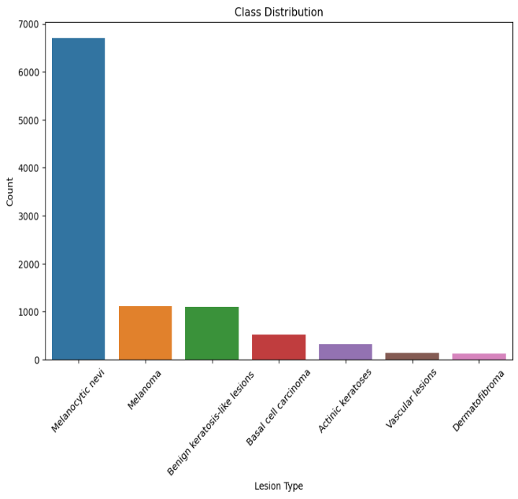

**FIGURE -1 [Classification of skin cancer]**

**Literature survey:**

The algorithms for detecting skin cancer, such as Support Vector Machines, VGG16, VGG19, Inception, Xception, and Convolutional Neural Networks (CNN), are compared in this research. The study assesses algorithm performance using a dataset of 30,000 skin pictures divided into training (21,000) and testing (9,000) sets. Analysis of skin lesions is made easier by machine learning, which helps in early cancer identification and prompt treatment. The results demonstrate CNN's superiority, with a 74% accuracy rate, underscoring its potential to enhance intervention and diagnosis precision. The results highlight the need for continued research to increase AI integration in clinical practices, incorporate large datasets, and improve algorithmic performance for better cancer diagnosis.[1]

Using image processing techniques, we developed a convolutional neural network (CNN) model in our research to accurately detect skin cancer. We performed a comparison analysis using seven alternative CNN architectures, namely ResNet50, VGG16, InceptionV3, VGG19, Xception, MobileNetV2, and MobileNet, using a dataset of approximately 3000 images classified into benign and malignant groups. With an accuracy of roughly 85.303%, Xception was found to be the most appropriate model despite differences in architecture. While tweaking parameters like epochs, batch size, and dropout may improve model performance, accuracy may be limited by factors like processing power and image quality. Notably, with an accuracy of 54.545%, MobilenetV2 showed the lowest accuracy.[2]

This study emphasises the significance of a precise diagnosis while examining the application of deep learning (DL) and machine learning (ML) approaches for early skin cancer prediction. A dataset that is accessible to the public is used to analyse different algorithms, such as CNNs and RF. With accuracy rates of 58.57% and 87.32%, respectively, without and with augmentation, RF performs better. Promising outcomes are also shown by MobileNetv2, an ensemble of DenseNet and Inceptionv3, which achieves accuracies of 88.81% and 88.80% without augmentation and 97.58% and 97.50% with augmentation. On both raw data and augmented datasets, customised CNN models with 5 and 3 layers achieve accuracy of 97.72% and 98.02%, respectively, indicating their potential for clinical integration. The effectiveness of transfer learning models is found to support their potential use in clinical practice, subject to additional validation and investigation.[3]

This study emphasises the significance of a precise diagnosis while examining the application of deep learning (DL) and machine learning (ML) approaches for early skin cancer prediction. A dataset that is accessible to the public is used to analyse different algorithms, such as CNNs and RF. With accuracy rates of 58.57% and 87.32%, respectively, without and with augmentation, RF performs better. Promising outcomes are also shown by MobileNetv2, an ensemble of DenseNet and Inceptionv3, which achieves accuracies of 88.81% and 88.80% without augmentation and 97.58% and 97.50% with augmentation. On both raw data and augmented datasets, customised CNN models with 5 and 3 layers achieve accuracy of 97.72% and 98.02%, respectively, indicating their potential for clinical integration. The effectiveness of transfer learning models is found to support their potential use in clinical practice, subject to additional validation and investigation.[4]

The need of an accurate diagnosis is emphasised in this study, which also looks at the use of deep learning (DL) and machine learning (ML) techniques for early skin cancer prediction. A publicly available dataset is analysed using various algorithms, including CNNs and RF. RF performs better, with accuracy rates of 58.57% and 87.32%, respectively, without and with augmentation. Additionally, MobileNetv2, an ensemble of DenseNet and Inceptionv3, displays promising results, achieving accuracies of 97.58% and 97.50% with augmentation and 88.81% and 88.80% without it. Customised CNN models with 5 and 3 layers obtain accuracy of 97.02% and 97.72% on both raw data and augmented datasets, respectively, suggesting their potential for clinical integration. It is discovered that transfer learning models are successful.[5]

This study clarifies lung cancer prediction in the context of the COVID-19 pandemic, a topic that has received less attention recently. Based on a synthesis of secondary metrics, tertiary indicators, and ROC curves, the research determines that random forest ensemble learning is the most effective method for lung cancer prediction through a thorough comparison of machine learning models. This emphasises how important it is to use cutting-edge algorithms to improve lung cancer preventive tactics.[6]

In order to lower death rates from skin cancer, this study investigates how well convolutional neural network (CNN) models perform in early skin cancer diagnosis. A dataset of pictures of benign and malignant skin cancer is used to assess different CNN architectures, such as VGG16, SVM, and ResNet50. The best accuracy of 93.18% was achieved by VGG16 in the results, demonstrating its efficacy in the classification of skin cancer.[7]

In order to detect hospital-acquired illnesses early, this study analyses the Ventilator-Associated Pneumonia (VAP) and Infection Risk Index (IRI) prediction models. It looks at how well they agree and disagree in predicting HAIs, offering guidance on how to use several disease-specific models at once. Through a better understanding of the behaviour of parallel infection detection models, this comparative analysis seeks to improve both hospital management and patient outcomes.[8]

**2.Methodolgy and Architecture:**

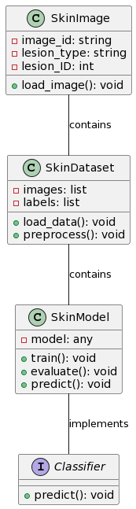

**Figure-2 [Architecture]**

The architecture of the skin cancer classification project is intended to efficiently categorise photos of skin lesions into several skin cancer subtypes. First, a wide range of skin image datasets are gathered, including different kinds of lesions such benign keratosis-like lesions, melanoma, and melanocytic nevi. Preprocessing is applied to these photos in order to improve model performance and guarantee consistency. Resizing, normalisation, and augmentation techniques are used in preprocessing to improve dataset diversity and standardise the format of the photos.

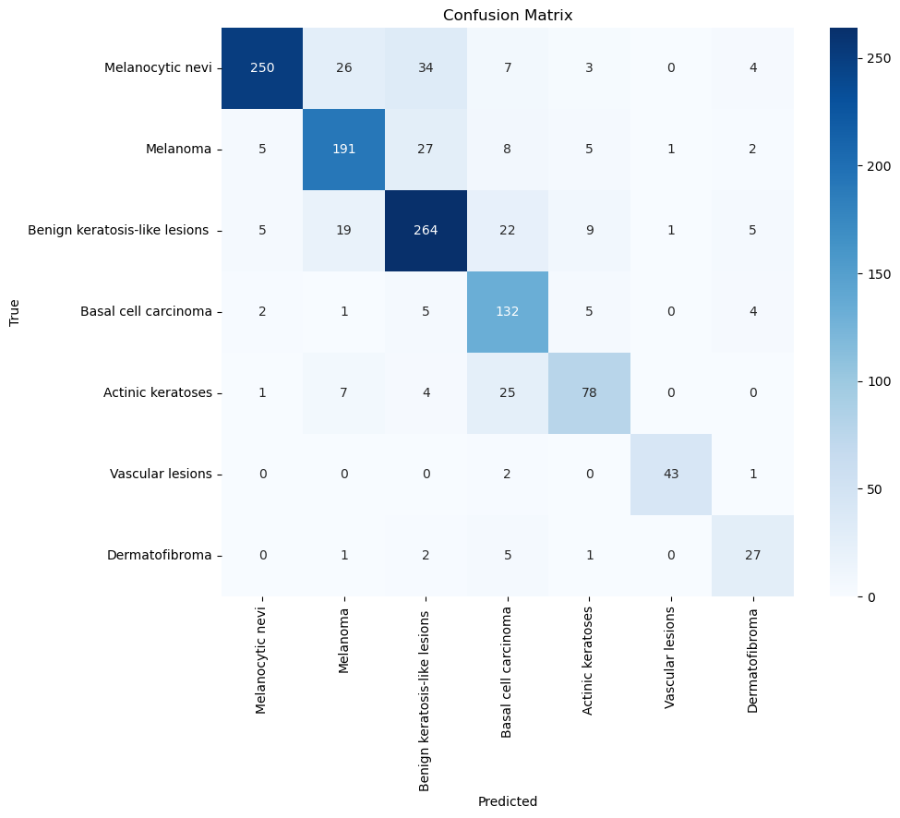

**FIGURE -3 [CONFUSION MATRIX]**

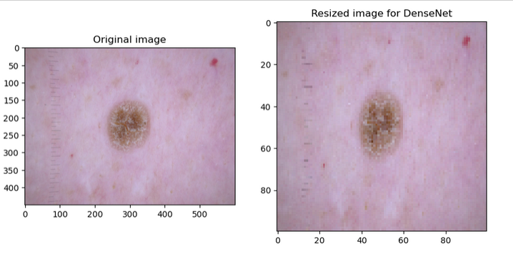

**FIGURE-4[PREPROCESSED IMAGES]**

A Convolutional Neural Network (CNN), a potent deep learning architecture renowned for its efficiency in image classification tasks, is then fed the preprocessed images. Convolutional layers for feature extraction, pooling layers for dimensionality reduction, and fully connected layers for classification are the several layers that make up a CNN. By modifying its internal parameters in response to the labelled data it receives, the CNN gains the ability to recognise patterns and features that correspond to various types of skin lesions during the training phase. The trained CNN model can be put to practical use in automated skin cancer diagnosis systems after satisfactory evaluation findings are obtained. In order to implement the model, it must be integrated into platforms or software applications that allow it to recognise input photos, classify them, and deliver end users or healthcare professionals diagnostic results. All things considered, the project's architecture makes it easier to accurately classify the many forms of skin cancer, which helps with early detection and efficient treatment plans.

**MODELS USED:**

**convolutional neural network:**   
  
Deep learning models called CNNs are created especially for image categorization applications.They are made up of several layers, such as pooling layers for dimensionality reduction and convolutional layers for feature extraction. Convolutional filters are used by CNNs to help them recognise patterns and features in images. They have demonstrated outstanding performance in the classification of skin cancer and are very useful for problems involving huge image datasets.

**RANDOM FOFREST:**

During training, several decision trees are built using the Random Forest ensemble learning technique.  
To arrive at a final forecast, it combines the predictions from each separate decision tree. Because of its versatility, Random Forest can be used for both regression and classification applications. It works well on high-dimensional data and is resistant to overfitting, which makes it appropriate for image classification applications such as the detection of skin cancer.

K-Nearest Neighbors (KNN):

KNN is a simple and intuitive classification algorithm based on instance-based learning. It classifies new data points by assigning them the majority class label among their k nearest neighbors in the training dataset. KNN is non-parametric and requires no training phase, making it computationally efficient for small to medium-sized datasets. It is sensitive to the choice of distance metric and the value of k.

**Linear Regression:**

Linear Regression is a basic regression algorithm used for predicting continuous numeric values.In the context of classification, it can be applied as a baseline model by converting the problem into a multi-class classification task.Linear Regression learns a linear relationship between the input features and the target variable.It is interpretable and computationally efficient but may not capture complex relationships in the data.

**Decision Tree:**

Decision Trees are hierarchical tree-like structures used for both classification and regression tasks.They partition the feature space into regions and assign a class label or numeric value to each region.Decision Trees are easy to interpret and visualize, making them useful for understanding feature importance.However, they are prone to overfitting, especially when dealing with high-dimensional data or complex relationships.

Conclusion:

Various machine learning techniques were utilised in this skin cancer categorization study to identify distinct kinds of skin lesions.

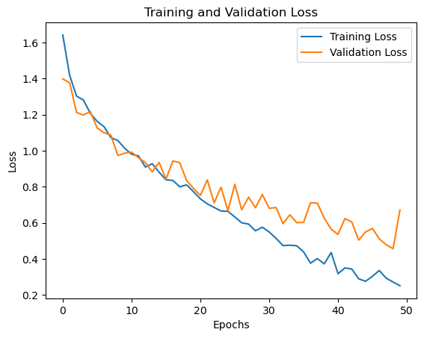

FIGURE-5[TRAINING LOSS VS VALIDATION LOSS]

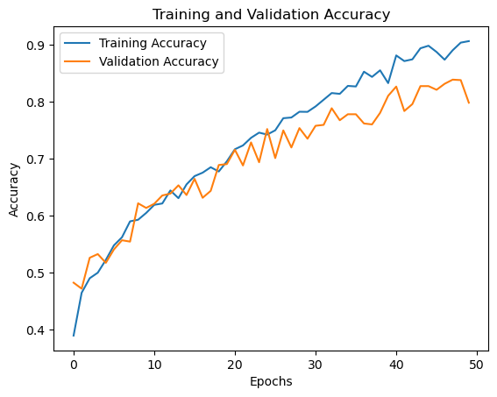

FIGURE-6[TRAINING ACCURACY VS VALIDATIONACCURACY]

With an astounding accuracy of 86.6%, the Convolutional Neural Network (CNN) was the best performance among these classifiers. CNNs are especially well-suited for image classification tasks like classifying different types of skin cancer because of their reputation for being adept at automatically extracting complex information from images. On the other hand, with only 33% accuracy, the Random Forest classifier performed worse than the others. Despite their robustness and versatility, Random Forests might have trouble capturing the subtle patterns found in photos of skin lesions. With an accuracy of 55%, K-Nearest Neighbours (KNN) performed mediocrely, demonstrating both its ease of use and sensitivity to hyperparameters. As a baseline model in this case, Linear Regression produced a Mean Squared Error (MSE) of 0.169, which is a decent but less reliable method. Compared to CNNs, Decision Trees offered a classification that was easier to understand but less accurate, with an accuracy rate of 47%. In the end, a variety of factors such as the dataset's complexity, interpretability, processing capacity, and accuracy needs will determine which classifier is best.

**References:**

[1] Shinde, P., & Ingle, Y.S. (2024). Skin Cancer Detection: A Review Using Machine Learning Techniques. Asian Journal of Research in Computer Science. [2] Hasan, H.A., & Ibrahim, A.A. (2020). Hybrid Detection Techniques for Skin Cancer Images. 2020 4th International Symposium on Multidisciplinary Studies and Innovative Technologies (ISMSIT), 1-8.

[3] Nancy, V.A., Prabhavathy, P., Arya, M.S., & Ahamed, B.S. (2023). Comparative study and analysis on skin cancer detection using machine learning and deep learning algorithms. Multimedia Tools and Applications, 82, 45913 - 45957.

[4] Singh, P.K., Kumar, M., & Bhatia, A. (2022). A Comparative Analysis of Deep Learning Algorithms for Skin Cancer Detection. 2022 6th International Conference on Intelligent Computing and Control Systems (ICICCS), 1160-1166.

[5] Rai, H.M., & Yoo, J. (2023). A comprehensive analysis of recent advancements in cancer detection using machine learning and deep learning models for improved diagnostics. Journal of Cancer Research and Clinical Oncology, 149, 14365 - 14408.

[6] Chen, J. (2023). Comparative Analysis of Machine Learning Models for Lung Cancer Prediction. 2023 IEEE International Conference on Image Processing and Computer Applications (ICIPCA), 242-246.

[7] Hasan, M.R., Fatemi, M.I., Monirujjaman Khan, M., Kaur, M., & Zaguia, A. (2021). Comparative Analysis of Skin Cancer (Benign vs. Malignant) Detection Using Convolutional Neural Networks. Journal of Healthcare Engineering, 2021.

[8] Harvey, E., Dong, J., Ghosh, E., & Samadani, A. (2023). A Comparative Analysis of Machine Learning Models for Early Detection of Hospital-Acquired Infections. ArXiv, abs/2311.09329.